Step by step guide for “Officer Reported Upon”.

- Open the url https://sparrow-cbic.rcil.gov.in/ in browser.

- The "Smart Performance Appraisal Report Recording Online Window" screen will open up which is essentially a login screen for SPARROW. The screen will have three fields "Username", "Password" and "Captcha".
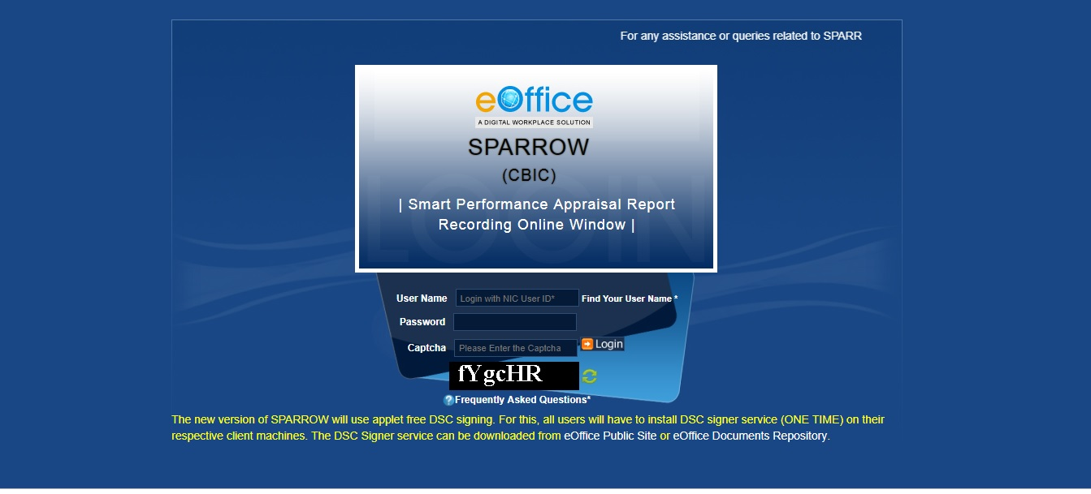
The username will be the NIC email id and only the name before "@" should be entered. For example if your NIC email is ashish.solanki@nic.in or ashish.solanki@gov.in, then, the user id will be ashish.solanki.
The password for the application will be same as your NIC email ID password.
The Captcha as given in the box should be entered then click the "Login" button. It would open a POP UP Window to verify and update the Adhaar number.

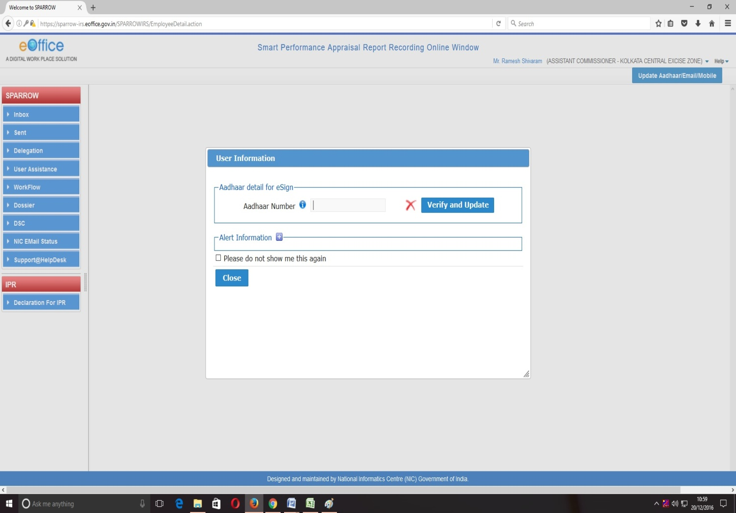

After verifying the Adhaar, the software would automatically move to next screen. By default, the SPARROW window will open up as shown in the next page.
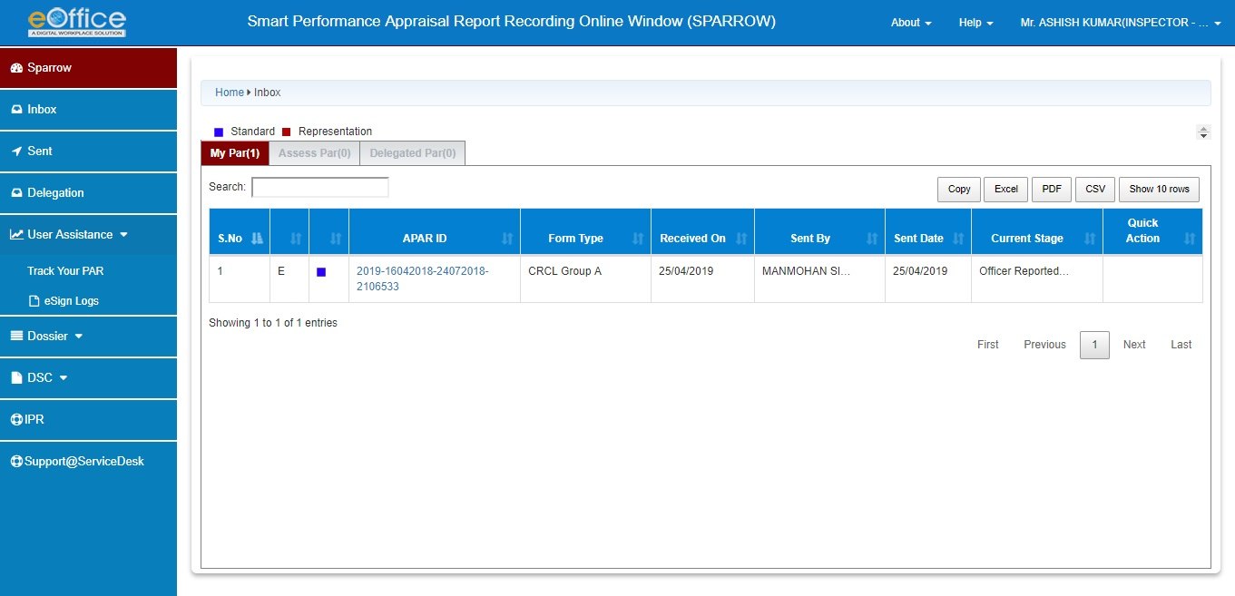
Above page is for the Officer Reported Upon. In the inbox, on clicking the My Par Tab, all the PARs generated by the Custodian shall be listed with their corresponding APAR-IDs (shown in blue colour) which are for the following work durations:
S.No. | From | To | Status
1. | 16/04/2018 | 24/07/2018 | Working

5. Now, the officer Reported upon will select the first PAR for the period 16/04/2018 to 24/07/2018 by clicking the APAR-ID for the relevant period. This would open section-I of the APAR as filled and generated by the Custodian (shown in the screen shotbelow).

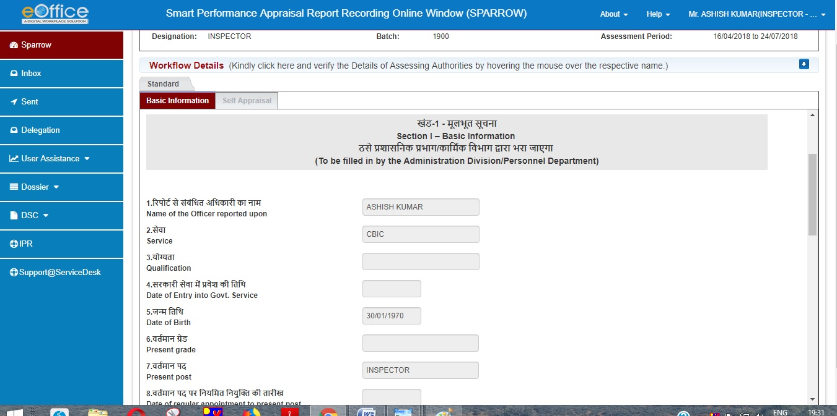

6. The Officer Reported Upon can check all his details filled in the Section-I which is name, Year of Allotment, Employee code, Date of Birth, work duration under Reporting and Reviewing Authority etc.
7. Further the officer has to check his leave details and trainings attended. These details would also be auto populated as they have been filled by Custodian.
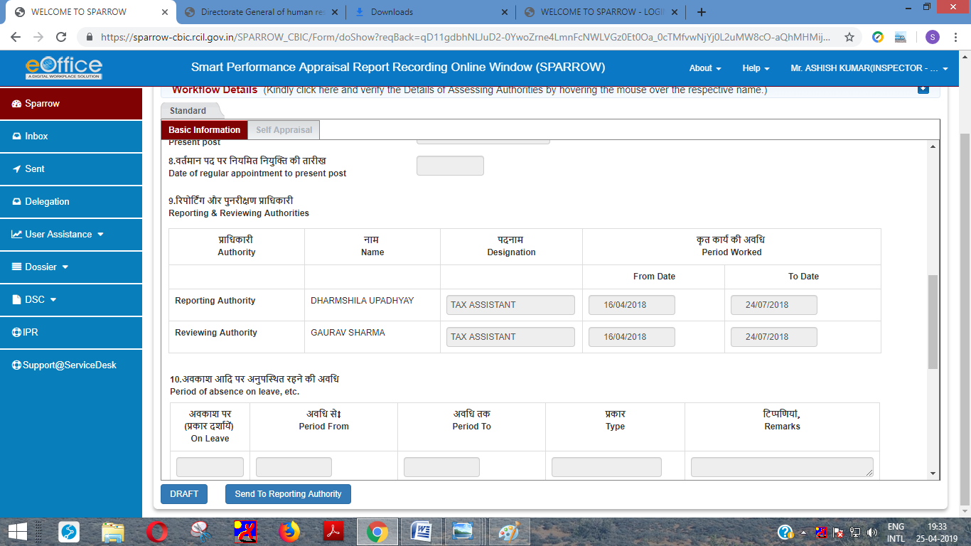

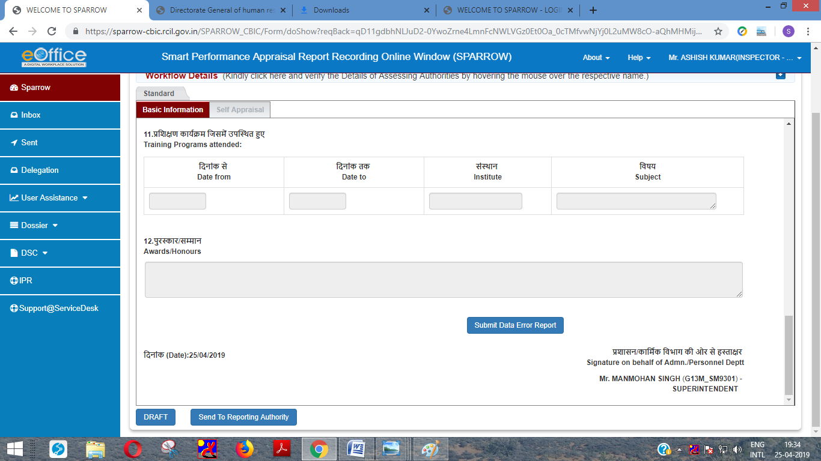
8. If any information is found to be incorrect then he can submit error report to Custodian by clicking Submit Error Report tab. If all the information filled in is correct, the officer can click Section-II of APAR and fill Section-II of APAR.

9. If he clicks Submit Error Report option following screen will open up which will have a text box. The officer can give the nature of errors / details which are to be corrected in the text box and click Submit button. This will send Section-I of the PAR to Custodian and thus allow Custodian to make requisite corrections to Section-I of the APAR.
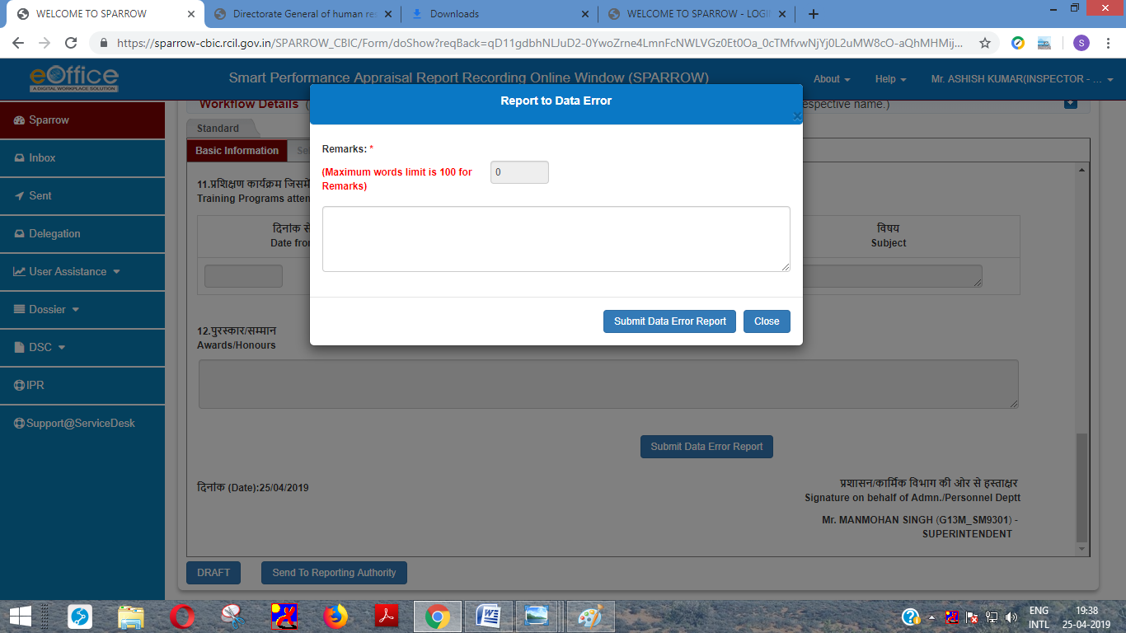

10. After clicking Submit a message would appear with text “Data Error Message is Reported Successfully” which means that the report has been sent to Custodian to make relevant changes.

11. After sending the error report, the officer should go to Self Appraisal of PAR and fill all his particulars for performance appraisal. The screenshots presented below shows the details of fields for Section-II which is same as that for the manual format of APAR.

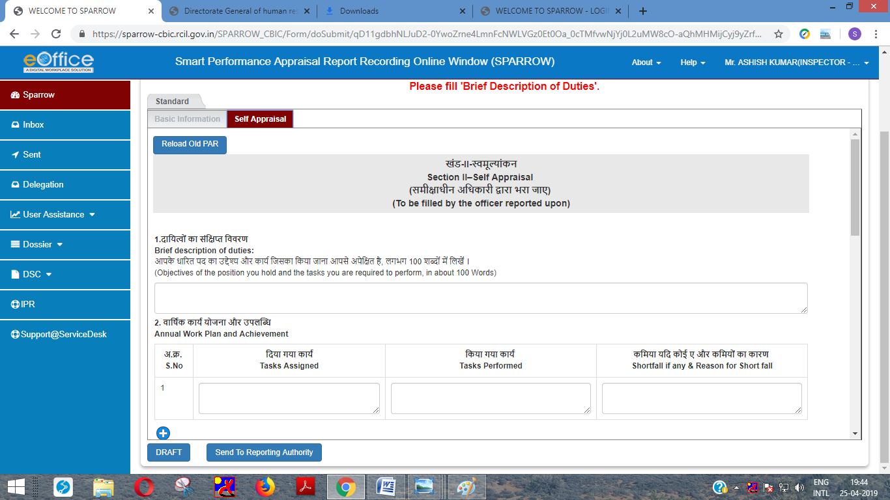
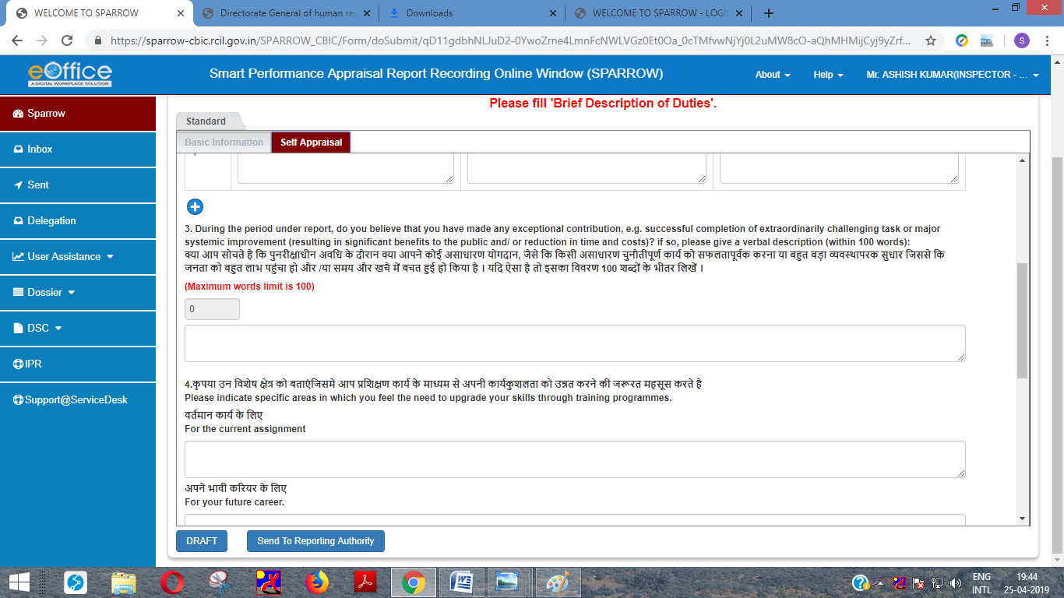
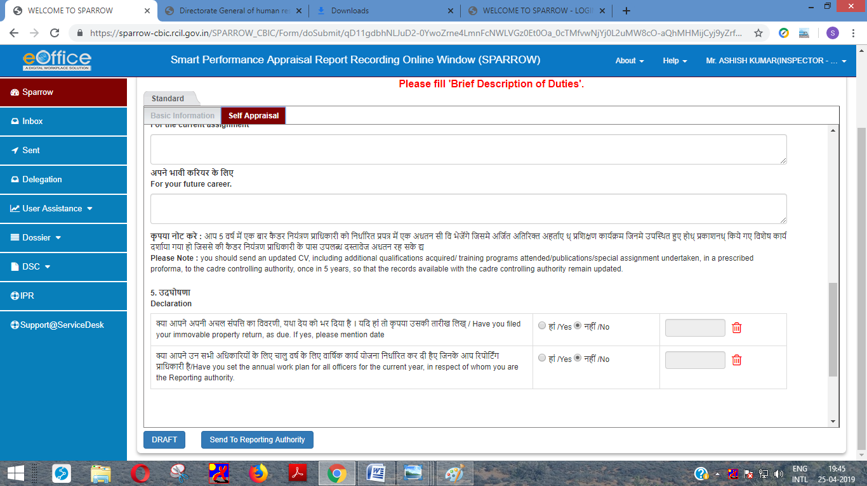
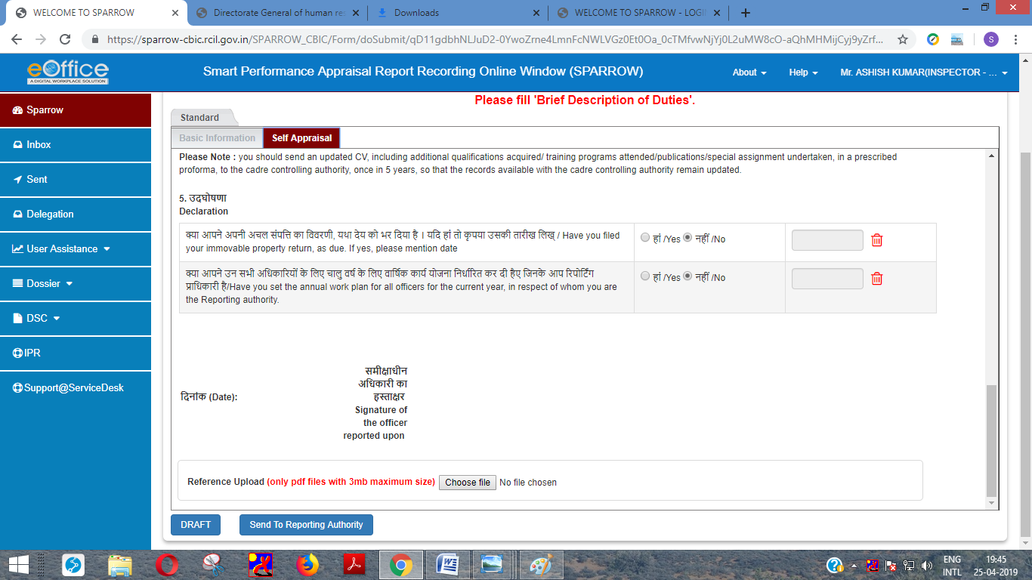

12. After filling all the details in Section–II, the officer can also upload any supporting documents in pdf format up to 3 mb by clicking Browse button.
13. The officer has an option to save the document and come back later to change/amend the same by clicking Save as Draft tab. Officers are also requested to keep on saving the document by clicking Save as Draft to avoid loss of data due to electricity failure or network connectivity issues.
14. Alternatively, the officer may send the PAR to Reporting officer after completing Section II of APAR for which the officer should click on Submit (Send to Reporting Authority). On clicking Submit button, a window asking OTP will appear in which you have to fill the OTP which will be received in your mobile linked with Adhaar card. After clicking this button a confirmation screen for submitting the Section II of APAR will appear with warning- “Once the form is submitted, data will not be changed. Are you sure you want to submit”.
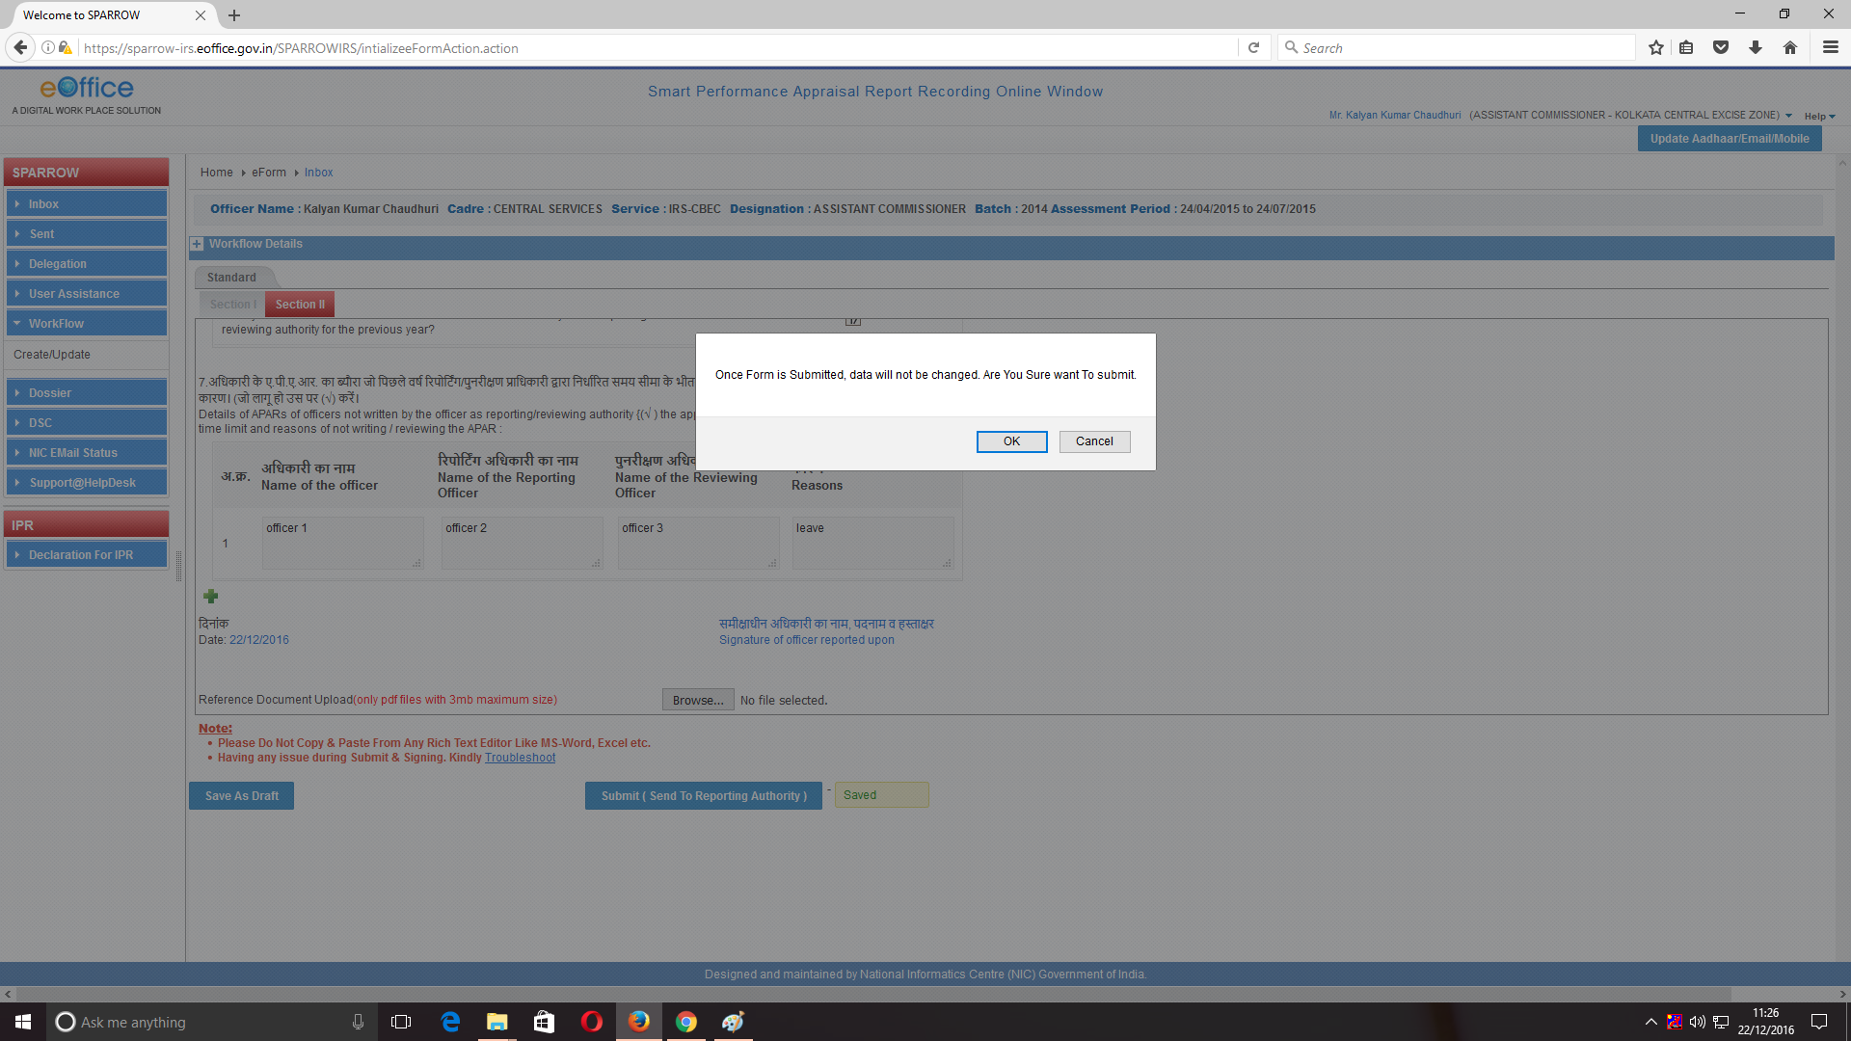

15. After pressing the OK button a message would pop up saying that the APAR has been sent to the Reporting Authority as shown in screen below. An email and SMS will also be sent to the Reporting Officer to this effect.

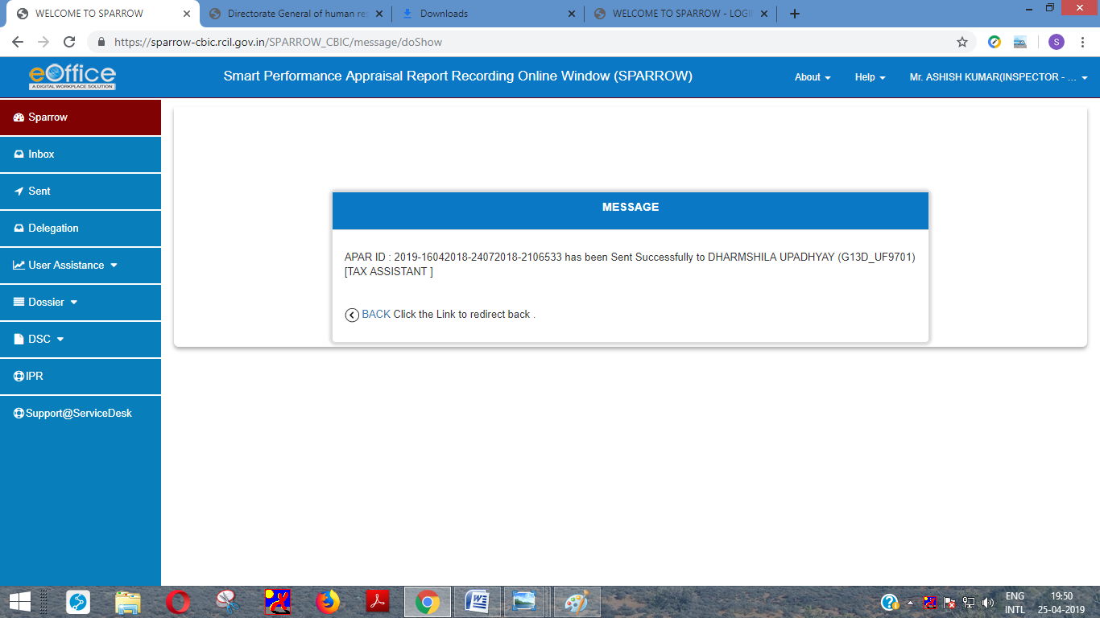

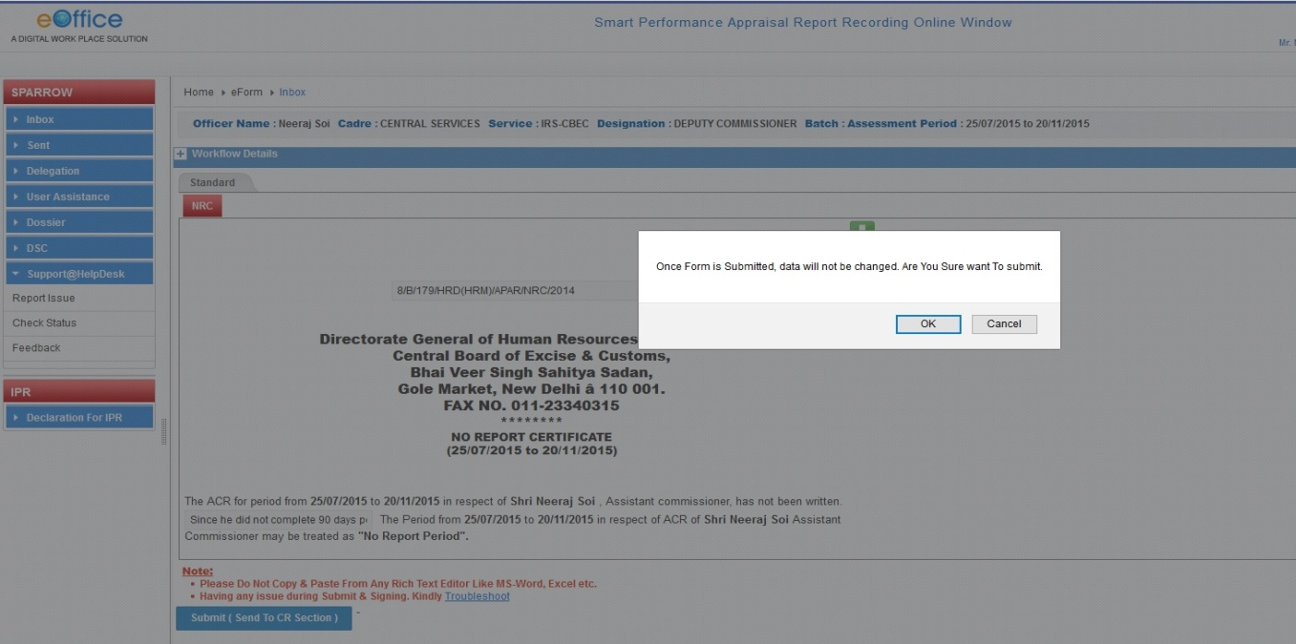

Acceptance of APAR or making representation by the Officer Reported Upon
16. Once Custodian discloses the completed APAR to the Officer Reported Upon, the APAR will be available in the My PAR tab and on clicking the Tab, following screen will appear.
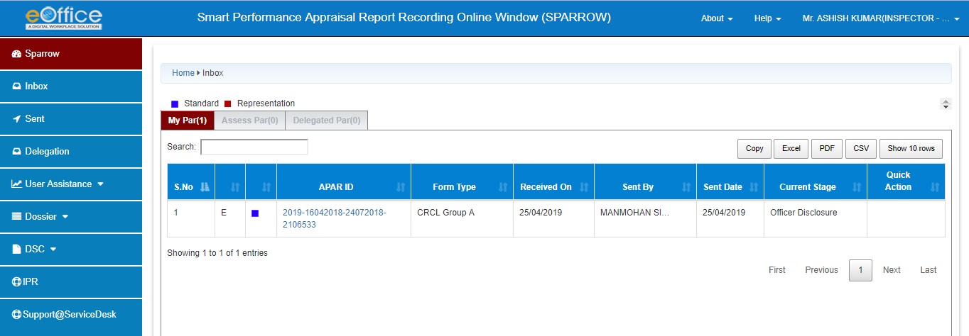
17. After clicking on APAR-ID, all four sections of APAR can seen by the Officer Reported Upon by clicking on different sections. The officer can also save this APAR by clicking on Preview Option as shown in the image in every section.
18. After clicking on Preview, the officer would have option to only open or SAVE the document. Click on SAVE File to make a copy in the computer.
19 . After viewing his Section III and Section IV the officer can either click on “I ACCEPT” the APAR or “PUT FOR REPRESENTATION”. If the officer clicks on I Accept Button, a confirmation message would pop up and APAR would be sent to the Custodian for closing.





