Step by step guide for the role of Reporting officer.
- Open the url https://sparrow-cbic.rcil.gov.in/ in browser.

- The "Smart Performance Appraisal Report Recording Online Window" screen will open up which is essentially a login screen for SPARROW. The screen will have three fields "Username", "Password" and "Captcha".
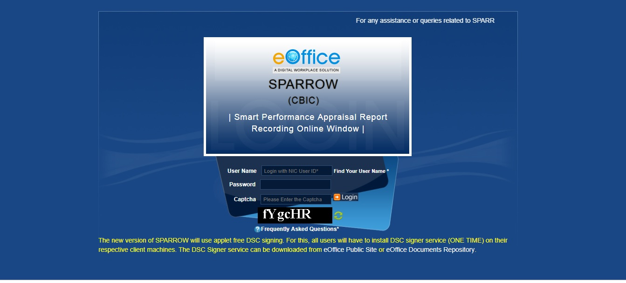
The username will be the NIC email id and only the name before "@" should be entered. For example if your NIC email is ashish.solanki@nic.in or ashish.solanki@gov.in, then, the user id will be ashish.solanki
The password for the application will be same as your NIC email ID password. However for practice environment, till software is launched, the default password for logging into the system is kept as "eoffice" for all the users.
The Captcha as given in the box should be entered then click the "Login" button.
- Your inbox will appear like this:
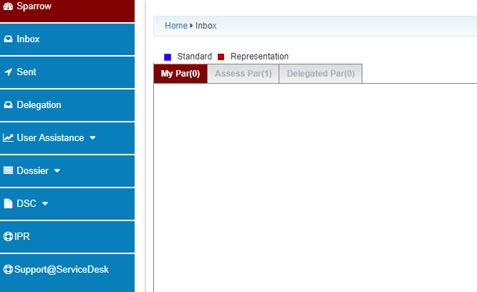

- Click on Assess PAR and then, on APAR ID
- 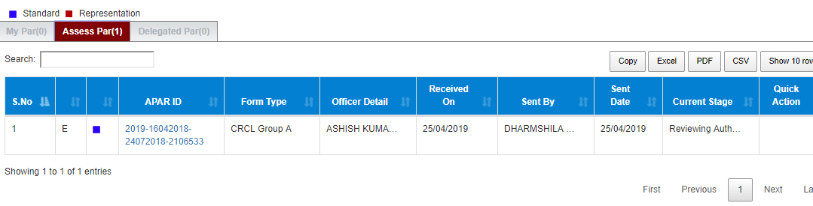
By Default, the Grades by Reviewing are same as that of Reporting Authority. If the Reviewing Authority wants to grade differently, he has to click on No , and then fill Grades in Section III
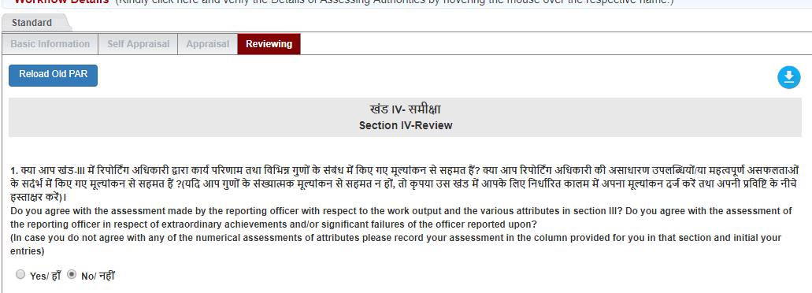
- After giving grades, and filling in Section IV, press send to CR section

- The following message appears
